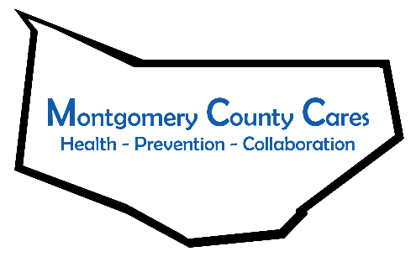
Montgomery County Cares
Meeting Minutes
Jan 12, 2022, Zoom

Attendance: Gwen Ossenkop, Kathy Stangle, Cassandra VanNostrand, Rachel Marcey, Sue Wendelgass, Rachel Truckenmiller, Kelley Gilligan, Mari Anne Suchocki, Brandy Richards, Brenda Hansson, Bonnie Peck, Sally Baker

TOPIC | DISCUSSION | OUTCOME/FUTURE ACTIONS
Welcome/Introductions
Approval of December 2021 minutes | 1-Rachel 2-Cassandra Approved
Spotlight Speaker: FulMont Community Action, Mari Anne Suchocki, CEO  PPGNY’s Rachel Marcey and Sue Wendelgass | FulMont Community Action serves residents in Fulton and Montgomery Counties from infants to senior citizens.  - Community Service Dept has outreach in Amsterdam, Ft. Plain, Fonda, and Gloversville offering emergency food, clothing, help with HEAP, tax help, Wheels for Work, Cars for Careers, care repairs  - WIC, Women Infants Children – a nutritional supplemental program for children up to 5 years. This program uses online services, debit card to upload money and certifications, no office appointment.  - Weatherization help for residents, ownership is not a requirement, landlord will just need to agree.  Senior Transportation for Fulton County.  - Early Childhood Services funded by Head Start and local school districts is a comprehensive preschool program. We are currently searching for 3-4 year olds to participate in our program. Our program typically services the neediest families in the community but all families should apply as we do have the availability to enroll families outside of our income guidelines.  LGTBQ & Youth Presentation by PPGNY –Excellent presentation! Highlights included LGBTQ definitions, explained gender, identities, gender expression, youth and substance use, varied LGBTQ experiences. Positive steps and behaviors to take include using inclusive language(proper nouns, names, words) make resources available, use visuals(stickers, posters, pins which are available for free-contact Rachel, Sue) to show acceptance and support, and resources. Rachel.marcey@ppgreaterny.org, 518-605-4664  Sue.Wendelgass@ppgreaterny.org, 518-584-0041 x 242229  -Is there a database with LGBTQ statistics? We need local data. -Is Gen Z more accepting? Yes and no, there are many variables. The loudest voice often wins, and recently the loudest voices have been mean bullies, which needs to change.  -Gwen will be sending out the PP slides.
New Business:  P-Tech Students  Meeting Change  Opioid Response Network  MCC NEU  DFC | P-Tech students want to work with MCC. They will be returning in February to campus and will attend the March meeting.  MCC will meet the second Tuesday at 1pm- TBA on start date.  A CADCA TA will provide a training in April. Topics to include importance of the 12 sectors tailored to MCC. In May there will be a ½ day training at FMCC-team building, DFC. This is open to the public, accommodate up to 100 people.  Gwen and Ginger are working with Catholic Charities, AHEC, Chief Thomas, APD, Sheriff May for the first NEU!  DFC year 1 is done! Time to take the yearly survey. The link was sent out, please complete! By-laws will have to be updated, please nominate people for the 2 chair positions for voting in Feb. We need to have 1 representative from each of the 12 sectors, Gwen will be contacting people shortly.

Member Reports None
Next Zoom meeting: Feb 9, 2022 @ 9:30AM
Next Month’s Spotlight Speaker: ____Lindsay Countryman from Alpha Pregnancy____________________________
Next Month’s Note Taker: _________Kelsey Carpe_______________________________

