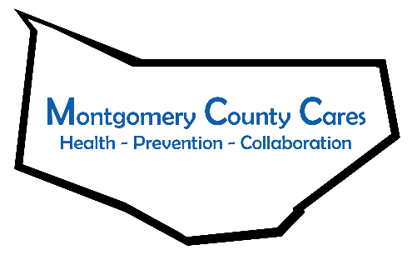
Montgomery County Cares
Meeting Minutes
Date of meeting:

Attendance: Gwen Ossenkop, MCC Coordinator; Ginger Cato, Recovery Center; Kim Shainberg, Safe Harbour; Sally Baker, CDTF; Sharleen Berenger, Nydia Hill, New Choices; Ariana Mattice-Lybrand, District Office Manager of Assemblyman Santabarbara; Alyssa Craig, Creative Connections Clubhouse; Kelsey Carpe, Cancer Prevention in Action; Nancy Deumaga, Mental Health Association; Lisa Cimo, Tina Morey, Sexual Assault Support Services; Kelley Gilligan, Catholic Charities Domestic Violence and Crime Victim Services; Laurie Bargstedt, HFM BOCES Adult Literacy; Michele Ciani, Catholic Charities; Kathy Stangle, Headstart; Elizabeth Aurand, St. John’s & St. Mark’s, Canajoharie; Vanessa Carey, Catholic Charities Emergency Assistance;

TOPIC | DISCUSSION | OUTCOME/FUTURE ACTIONS
Welcome/Introductions
Approval of minutes | 1st: Vanessa, 2nd Nydia. Approved.
Spotlight Speaker | Cheyenne Lovell from Catholic Charities DV Services shared a video on the Resources available in Fulton and Montgomery Counties. The video will be shared with the coalition members.
Old Business
Capacity Survey | Capacity Survey due by 3/10 | Gwen will announce winner of gift card of those who submitted the survey
Capacity Survey Action Team | 2 members needed to join to review the capacity survey and create an action plan from the results. | Sally Baker and Sharleen Berenger volunteered; they will be meeting with Gwendolyn and Ginger to review the survey and how to move forward with the data
New Logo | FMCC Students are working on updating the Montgomery County Cares logo | Gwen will email out the logos when complete and the coalition will vote on them during the April meeting
Co-Chair | Sharleen Berenger nominated and voted on as new co-chair of MCC | Approved.
New Business
CADCA Academy Update | -Need to create a logic model w/ an action team; this will establish what goals the coalition has and how to get there  -2019 survey does not provide enough data and the coalition will be working with Law Enforcement to gather more, along with compliance checks  -Focus groups with parents and students will begin at the end of March  -Gwen and Ginger are working on the community scan | If interested in being apart of the action team, please reach out to Gwen  -There will be more information in April
Annual Family Dinner | -Annual family dinner night is scheduled for September 27, 2021 at the Century Club  -Volunteers will be needed for this event! | More info to come,
Coordinator updates | -March 22-28th is National Drug and Alcohol Awareness Week  -Gwen has registered for a few events; watch the facebook page for more information and videos etc.  -Key Informant Survey; learning what members of the community believe the problems facing the community are  -Environmental Scan has begun  -Made contact with PTECH to discuss the possibility of creating a youth coalition  -Working with LPP for parent involvement  -Coalition is being highlighted by CADCA

Member Reports
Vanessa (Catholic Charities Emergency Assistance): Funds available to help people with rent and National Grid bills.
Laurie (Adult Literacy): Services still being offered; IC3 is available as a training to help someone to gain basic technical skills to help with employment.
Kathy (Headstart): Headstart will be going to 4 days a week; enrolling 3 and 4 year olds for the fall season; Part time positions available.
Alyssa (Creative Connections): Triple P parenting for parents of teens is now available; a flyer will be out soon.
Cassandra (Planned Parenthood): Planned Parenthood in Amsterdam is open for in person and telehealth appointments; Cassandra is available for any outreach and education needs, contact at cassandra.vannostrand@ppgreaterny.org

Next Zoom meeting: Wednesday, April 14, 2021 @ 9:30 AM
Next Month’s Spotlight Speaker: Laurie B, HFM BOCES
Note Taker: Shar Berenger

